**Exercise**

1. In shopping for a new house, you must consider several factors. In this problem the initial cost of the house, the estimated annual fuel costs, and the annual tax rate are available. Write a program that will determine the total cost of a house after a five-year period and run the program for each of the following sets of data.

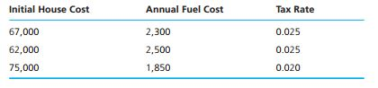

To calculate the house cost, add the initial cost to the fuel cost for five years, and then add the taxes for five years. Taxes for one year are computed by multiplying the tax rate by the initial cost. Write and call a function that displays instructions to the program user

1. A parking garage charges a $2.00 minimum fee to park for up to three  
   hours and an additional $0.50 per hour for each hour or part thereof over three hours. The maximum charge for any given 24-hour period is $10.00. Assume that no car parks for longer than 24 hours at a time. Write a program that will calculate and print the parking charges for each of three customers who parked their cars in this garage yesterday. You should enter the hours parked for each customer. Your program should print the results in a tabular format, and should calculate and print the total of yesterday's receipts. The program should use the function calculateCharges to determine the charge for each customer. Your outputs should appear in the following format:

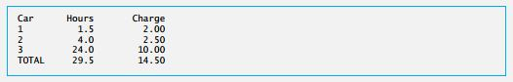

1. Define a function called hypotenuse that calculates the length of the hypotenuse of a right triangle when the other two sides are given. The function should take two arguments of type double and return the hypotenuse as a double. Test your program with the side values specified in Fig

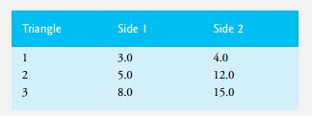

1. Write a function distance that calculates the distance between two points (x1, y1) and (x2, y2). All numbers and return values should be of type double.
2. The Fibonacci series

0, 1, 1, 2, 3, 5, 8, 13, 21, …

begins with the terms 0 and 1 and has the property that each succeeding term is the sum of the two preceding terms. a) Write a nonrecursive and recursive function fibonacci(n) that calculates the nth Fibonacci number. Use unsigned int for the function’s parameter and unsigned long long int for its return type. b) Determine the largest Fibonacci number that can be printed on your system

1. Write a program that simulates coin tossing. For each toss of the coin the program should print Heads or Tails. Let the program toss the coin 100 times, and count the number of times each side of the coin appears. Print the results. The program should call a separate function flip that takes no arguments and returns 0 for tails and 1 for heads. [Note: If the program realistically simulates the coin tossing, then each side of the coin should appear approximately half the time for a total of approximately 50 heads and 50 tails.]